Writing

We have reviewed the Steps in the Writing Process (pre-writing, drafting, editing, revising, publishing/presenting) and the Six Traits of Writing (ideas, organization, voice, word choice, sentence fluency, conventions).

Writing assignments are assigned periodically. The next assignment is a mini-biography or biographical sketch. It must be someone the student knows and can interview, not someone “famous.” They also have the option of writing about Mr. William Shelnutt, our Head of School. We will interview him on Tuesday in class. A rough draft will be due by Monday, Sept. 14th. We will be using peer review for the editing process, but you can also help proofread at home.

Reading

Stories –

“A Days Wait” by Ernest Hemingway.

Excerpt from *Tiger: A Biography of Tiger Woods* by John Strege

“Seventh Grade” by Gary Soto

We also have taken notes on some of the authors we have read.

**Don’t forget AR goals! I will send home progress toward goals in the progress report under comments, but won’t add the grade until afterwards.**

Students reviewing for the noun/pronoun test in an activity called Scoot.

We just completed our assessment on nouns and pronouns as part of our grammar review and study. Looking ahead to verbs, more writing and reading.

Vocabulary

Vocabulary words will come from the Giggles in the Middle book and the short stories or novels we are reading. This week’s words are from the introduction and Caught ya’ sentences from *Giggles in the Middle,* as well as stories.

**vapid waggish regaled**

**articulate aspiration sagacious**

**deter affront glowered**

**prodigious prestigious portly**

**conviction scowl insipid**

**sheepishly deftly clamor**

**erudite**

**2nd Vocab Quiz on Sept. 9th**

Grammar

In grammar, we will begin with a review of the parts of speech, focusing next on verbs.

Each week, we will take notes on the grammar skill presented, in this case action, linking and helping verbs. In addition, we will utilize the Daily Grammar Practice (DGP) which uses repetition and a format that remains the same, though the sentences will change. We are also continuing our Caught ‘Ya sentences daily. I collected this week’s set (Sept. 1-4) for a daily grade. I will collect them periodically throughout the year. When we begin reading the class novels, we will also incorporate grammar skills with excerpts from the book.

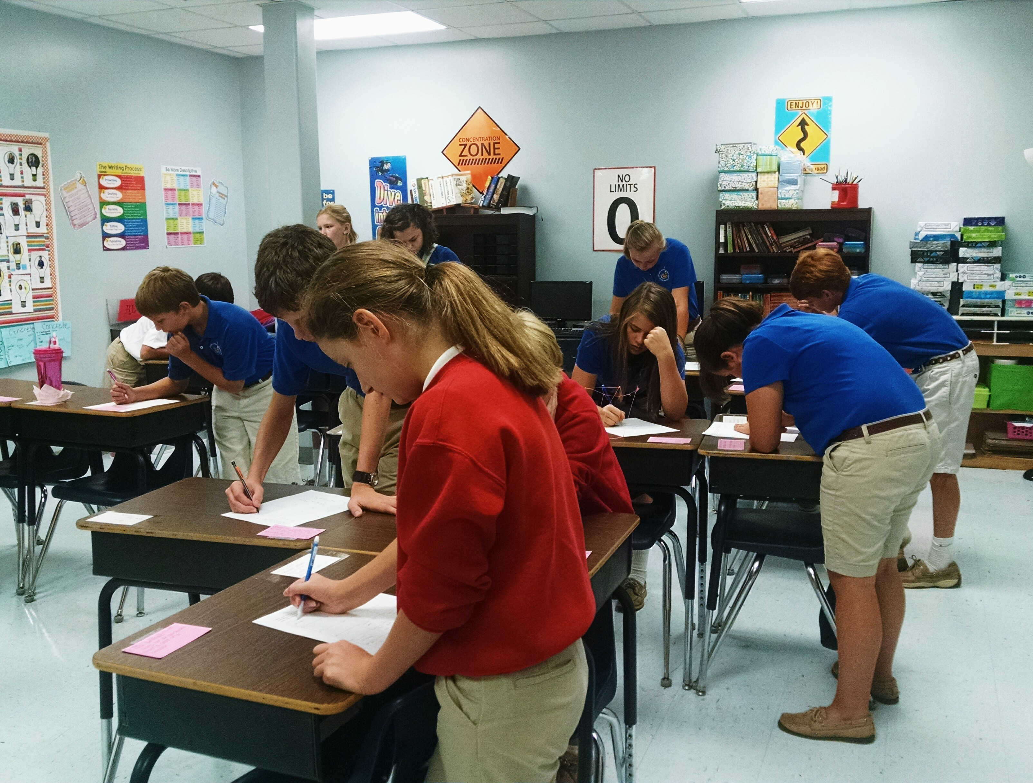

7th grade Language Arts

Weeks 4 & 5

Grammar, Writing, Vocabulary